


SMARTFLOW: Intelligent Water Utility Management System
IET ASSIGNMENT REPORT
Submitted in the partial fulfilment for the Course of
CSA0509 – Database Management Systems
to the award of the degree of
BACHELOR OF TECHNOLOGY
IN
Computer Science And Engineering

Submitted by
Lokesh S (192511037)

Under the Supervision of
Dr. R. Kesavan

Professor

SIMATS ENGINEERING
Saveetha Institute of Medical and Technical Sciences
Chennai-602105
September 2026

CHAPTER 1: INTRODUCTION

1.1 Background
Municipal water utilities generate continuous operational information from customer connections, smart meters, billing systems, payment channels, complaint desks, and field operations. A database system must therefore support both transactional workloads and append-heavy telemetry workloads. SMARTFLOW is proposed as a unified platform that places the relational database at the center of these activities.

1.2 Problem Statement
A conventional utility application may store customer details, readings, bills, payments, and complaints without demonstrating how the underlying DBMS handles high-volume data, indexing, concurrency, and transaction safety. The project addresses this gap by designing a system in which major operational actions can be connected directly to DBMS concepts.
- High-volume meter readings require efficient historical range retrieval.
- Latest-reading lookups should not repeatedly scan the telemetry table.
- Concurrent bill generation must not create duplicate invoices.
- Payment updates must preserve account balances under concurrent access.
- Leak analysis should compare recent consumption against a historical baseline.
- Database optimization should be demonstrable through real EXPLAIN plans and measurements.

1.3 Objectives
- Design a normalized MySQL database for water utility operations.
- Demonstrate indexed-sequential telemetry organization using B+Tree indexes.
- Implement an application-level hash table using modulo hashing and separate chaining.
- Provide transaction-safe billing and payment workflows.
- Demonstrate concurrency control using row locking and optimistic versioning.
- Provide Query Lab, Transaction Center, Concurrency Lab, and Performance Lab modules.
- Produce a structured academic report and evidence plan for evaluation.

1.4 Scope
The proposed scope covers zones, connections, meters, readings, leak intelligence, billing, payments, complaints, audit logs, database labs, reporting, and role-based access. The design includes both operational pages and academic demonstration pages.

1.5 Significance
The significance of SMARTFLOW lies in making DBMS concepts visible through a realistic domain. Instead of treating SQL as a collection of CRUD statements, the project connects schema design, constraints, indexes, transactions, locks, query plans, and data structures to real utility workflows.

1.6 Organization of the Report
Chapters 1–12 progressively cover the problem, literature, requirements, architecture, database design, DBMS concepts, implementation plan, testing, performance evaluation, security, conclusions, and supporting appendices.

CHAPTER 2: LITERATURE REVIEW

2.1 Introduction
Modern utility information systems increasingly depend on centralized relational databases, telemetry platforms, analytics, and secure web interfaces. Database design remains important because operational information must be consistent while telemetry workloads can become very large.

2.2 Utility Management Information Systems
Utility systems typically combine customer account management, metering, billing, payments, service requests, and operational monitoring. These functions produce different access patterns: account data is transactional, while meter readings are sequential and time-oriented.

2.3 Database Management in Utility Systems
Relational DBMS principles such as normalization, primary and foreign keys, constraints, indexing, transactions, and recovery are directly applicable to utility management. SMARTFLOW uses these principles as the foundation of its design.

2.4 Indexing and B+Tree Access
B+Tree indexes are appropriate for equality and range predicates. A composite index beginning with connection_id and followed by reading_timestamp supports retrieval of a connection's readings over a time window.

2.5 Hashing in Database Applications
Hash tables provide expected constant-time point lookup when the hash distribution is appropriate. SMARTFLOW intentionally keeps the academic hash demonstration at the application layer rather than incorrectly describing a MySQL InnoDB B+Tree index as a hash table.

2.6 Transactions and Concurrency
Transaction processing protects multi-step updates through atomic commit and rollback. Concurrency control is required when two operators access the same bill or complaint simultaneously. SMARTFLOW combines database constraints, row locks, and version tokens.

2.7 Research Gap
The project focuses on integrating several DBMS topics into one coherent demonstrator: telemetry indexing, hashing, leak analytics, billing transactions, concurrency experiments, query-plan visualization, and benchmark evidence.

2.8 Summary
The review establishes the need for a system that is both operationally meaningful and academically demonstrative. SMARTFLOW is designed around this combination.

CHAPTER 3: SYSTEM ANALYSIS

3.1 Existing System
The existing-system model considered in this project represents fragmented utility operations in which customer records, meter readings, billing, complaints, and operational monitoring may be managed separately or without explicit DBMS demonstrations.

3.2 Limitations
- Repeated scans of large telemetry tables.
- Weak visibility into query execution plans.
- Risk of duplicate billing in concurrent workflows.
- Limited demonstration of ACID behavior.
- Manual investigation of abnormal consumption.
- Insufficient traceability of sensitive financial and operational changes.

3.3 Proposed System
SMARTFLOW centralizes utility data and provides a command-center interface backed by MySQL. The system includes operational modules and dedicated DBMS laboratories so that evaluators can inspect both application behavior and database behavior.
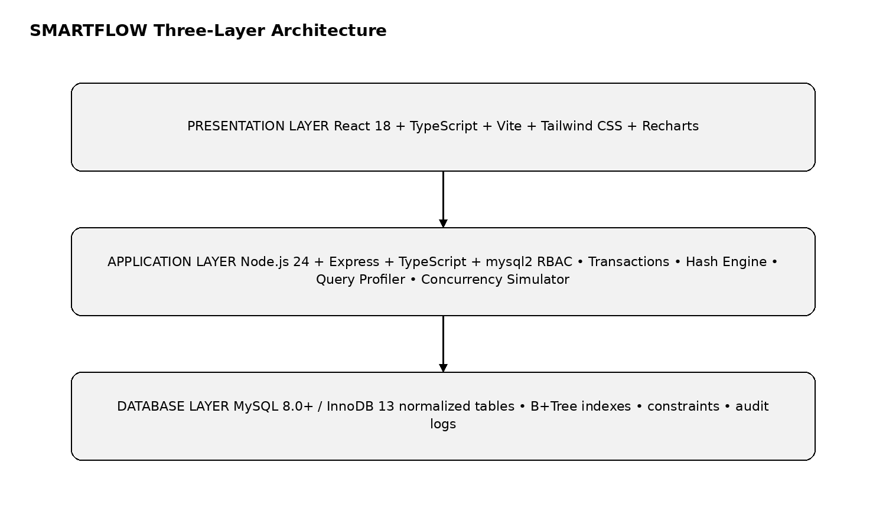
Figure 3.1: Proposed SMARTFLOW three-layer architecture.

3.4 Functional Requirements
Module | Key Functions
Dashboard | KPIs, consumption trends, zone summaries, priority actions
Connections | Search, filters, connection profile, 360° history
Meter Readings | Telemetry stream, historical range queries, status filters
Leak Intelligence | Baseline calculation, deviation scoring, inspection tickets
Billing | Cycle management, tier calculation, duplicate prevention
Payments | Ledger posting, balance reconciliation, receipts
Complaints | Ticket lifecycle, assignment, OCC version checks
Query Lab | Before/after SQL and EXPLAIN analysis
Transaction Center | BEGIN, SAVEPOINT, COMMIT, ROLLBACK demonstrations
Concurrency Lab | Dual-session lock and race-condition experiments
Performance | Latency, row scans, access type, throughput
Reports | CSV/printable reports and audit information

3.5 Non-Functional Requirements
Requirement | Description
Security | Authentication, RBAC, parameterized SQL, audit logging
Performance | Indexed access paths and measurable query latency
Reliability | Atomic transactions and rollback on failure
Scalability | Batch seeding and support for large telemetry datasets
Usability | Clean, data-dense civic-tech interface
Maintainability | Modular backend and frontend structure

3.6 Hardware Requirements
Component | Recommended Requirement
Processor | Intel Core i3 / equivalent or better
RAM | 8 GB or above recommended
Storage | At least 10 GB free for development datasets
Display | 1366 × 768 or higher
Network | Local network / internet where required for development services

3.7 Software Requirements
Software | Purpose
MySQL 8.0+ | Relational database and InnoDB transaction engine
Node.js 24 | Backend runtime
TypeScript | Backend/frontend type safety
Express | REST API server
mysql2 | Raw parameterized SQL access
React 18 + Vite | Frontend application
Tailwind CSS | UI styling
Recharts | Charts and analytics visuals
Git | Version control

3.8 User Roles
Role | Primary Access
ADMIN | Full system management, seeding, settings, DBMS labs
BILLING_OPERATOR | Billing and payment operations
FIELD_ENGINEER | Meter, leak, and field inspection operations
COMPLAINT_OPERATOR | Complaint assignment and lifecycle management

3.9 System Workflow
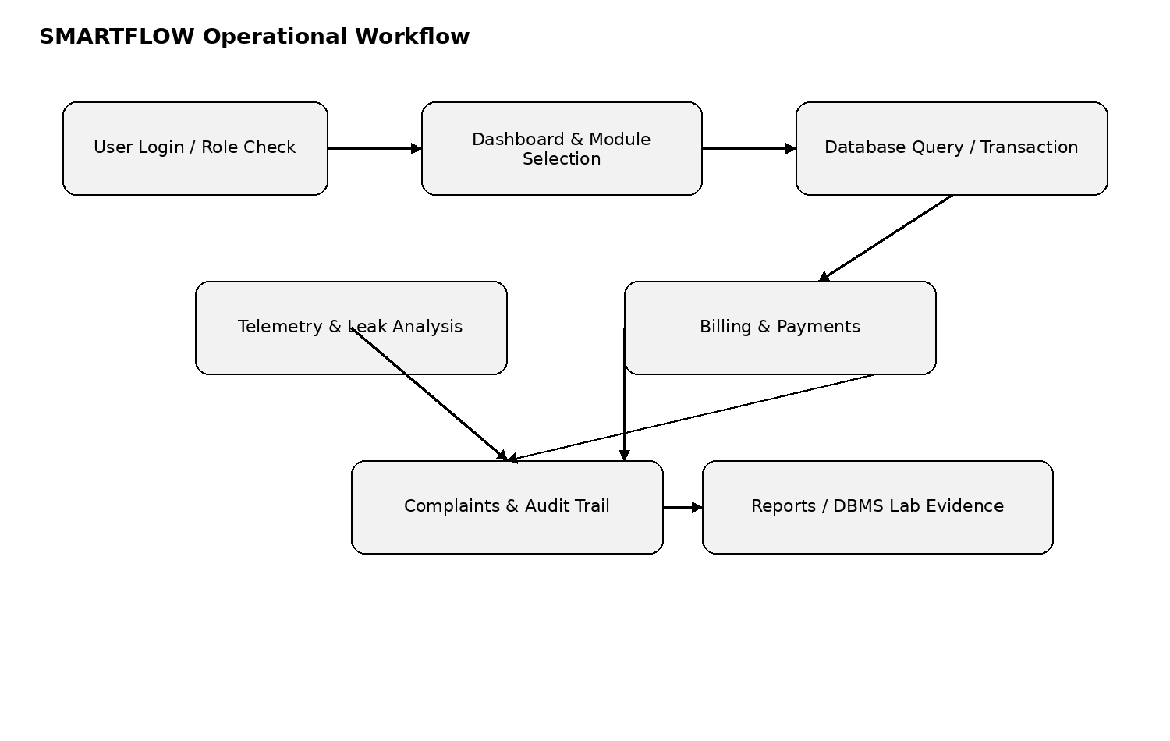
Figure 3.2: High-level SMARTFLOW operational workflow.

3.10 Summary
The analysis establishes the system requirements and shows how each operational need maps to a DBMS mechanism.

CHAPTER 4: SYSTEM DESIGN

4.1 System Architecture
SMARTFLOW follows a presentation–application–database architecture. The frontend provides responsive dashboards and data-dense operational screens. The backend provides REST APIs, transaction orchestration, hashing, profiling, and concurrency simulation. MySQL InnoDB provides persistence, constraints, locking, and recovery.

4.2 Technology Stack
Layer | Technology | Role
Frontend | React 18, TypeScript, Vite | Web interface and interaction
UI | Tailwind CSS, Lucide Icons | Design system and icons
Charts | Recharts | Telemetry and performance visualizations
Backend | Node.js 24, Express, TypeScript | API and business logic
Database Access | mysql2 | Prepared SQL and transaction control
Database | MySQL 8.0+, InnoDB | Persistent relational data
Testing / Benchmarking | Node.js scripts | Validation and performance measurement

4.3 Module Design
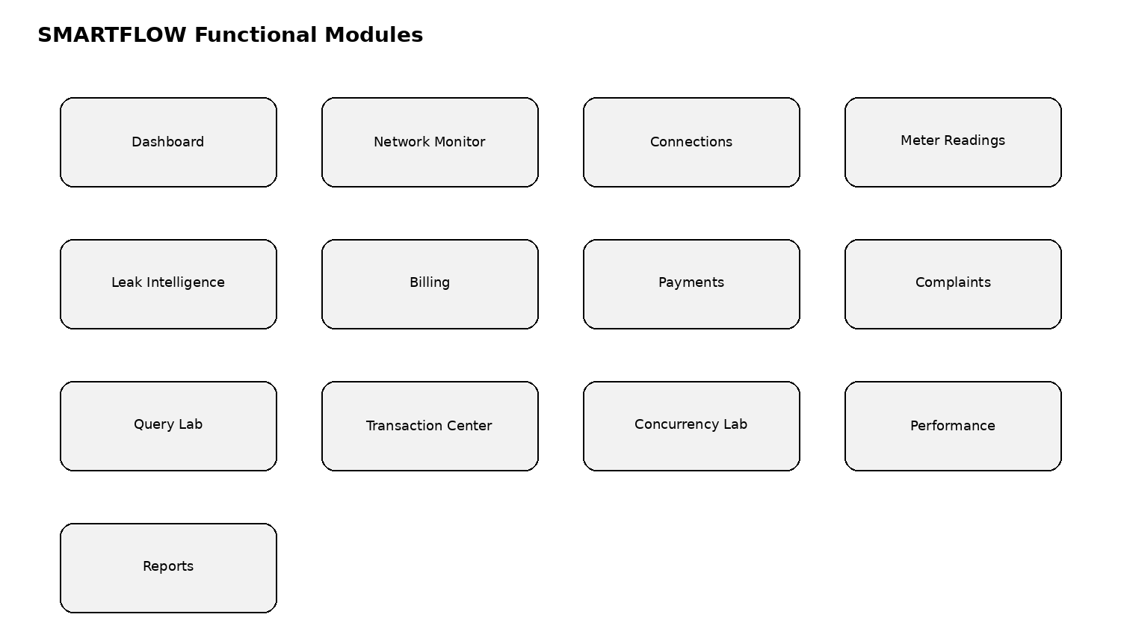
Figure 4.1: SMARTFLOW functional module map.

4.4 Data Flow Design
Operational data flows from users and meter telemetry into the application layer. Validated requests are converted into parameterized SQL. The database returns rows or transaction outcomes, and the application converts them into dashboards, tables, alerts, receipts, and lab visualizations.

4.5 Use Case Design
Actor | Representative Use Cases
Admin | Manage users, seed data, inspect audits, access all DBMS labs
Billing Operator | Generate bills, post payments, reconcile balances
Field Engineer | Inspect readings, investigate leaks, update field status
Complaint Operator | Create, assign, progress, and close complaints
System / Database | Enforce constraints, locks, indexes, transactions, recovery

4.6 ER Design
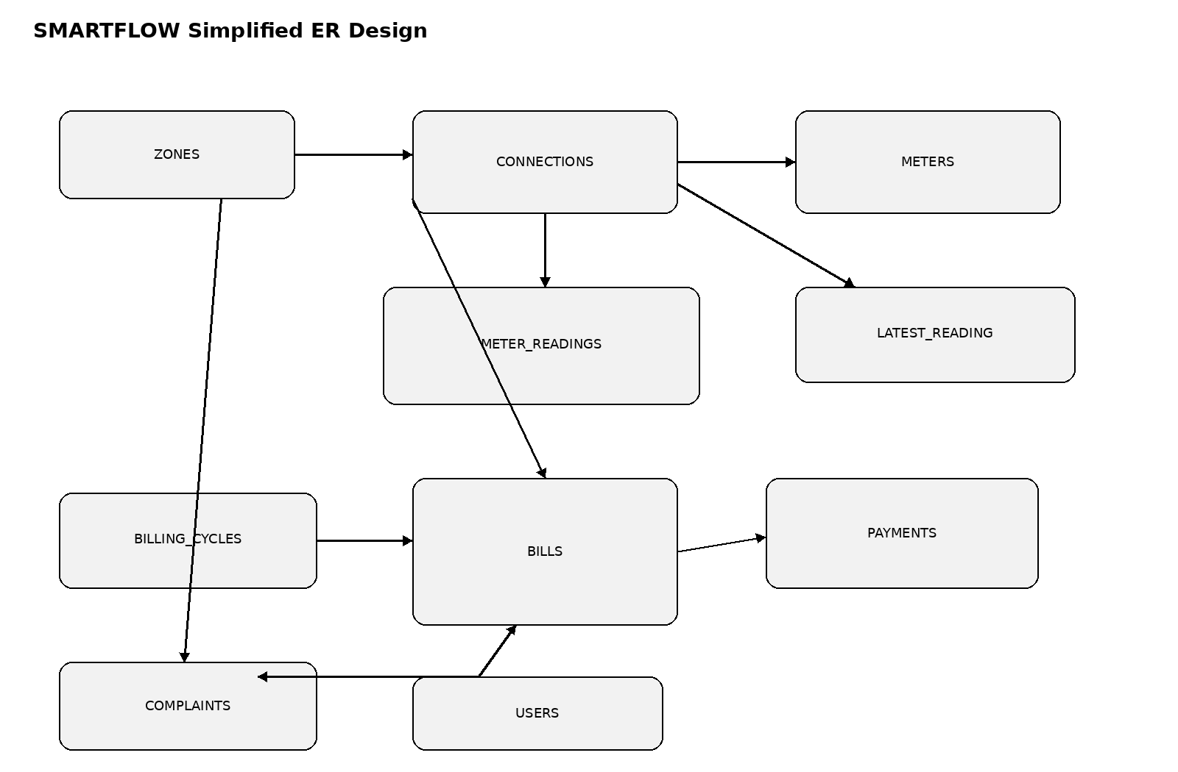
Figure 4.2: Simplified SMARTFLOW entity relationship design.

4.7 Security Design
Security is designed around role-based access, password hashing, parameterized SQL, environment-based database credentials, and audit logging. Client bundles must not contain database credentials.

4.8 Summary
The design translates the requirements into modules, data flows, actors, and a layered architecture.

CHAPTER 5: DATABASE DESIGN

5.1 Database Overview
The proposed database is named smartflow_db and contains 13 normalized tables: users, zones, connections, meters, meter_readings, latest_meter_reading, billing_cycles, bills, bill_items, payments, complaints, complaint_history, and audit_logs.

5.2 Normalization Strategy
The schema separates entities according to their responsibilities and uses primary and foreign keys to represent relationships. Repeating groups and multi-valued operational data are stored in dedicated tables such as bill_items and complaint_history.

5.3 Core Tables
Table | Purpose
users | System actors and roles
zones | Municipal distribution zones
connections | Customer water service endpoints
meters | Smart meters assigned to connections
meter_readings | High-volume telemetry
latest_meter_reading | Current reading per connection
billing_cycles | Monthly billing periods
bills | Utility invoices
bill_items | Tariff line-item breakdown
payments | Payment settlement ledger
complaints | Citizen service tickets
complaint_history | Complaint status audit trail
audit_logs | System-wide forensic activity log

5.4 Primary and Foreign Keys
Primary keys uniquely identify rows. Foreign keys maintain referential integrity between zones and connections, connections and meters/readings, billing cycles and bills, bills and payments, complaints and their histories, and users involved in controlled operations.

5.5 Constraints
- UNIQUE(account_number) for customer accounts.
- UNIQUE(connection_id, cycle_id) for duplicate-bill prevention.
- UNIQUE(transaction_reference) for payment idempotency.
- CHECK(amount > 0) for payments.
- CHECK constraints for valid billing cycle month/year values.
- Foreign keys with deliberate DELETE behavior.

5.6 Database Schema Evidence
Before final submission, capture an actual MySQL Workbench or CLI screenshot showing all 13 created tables and their relationships. The screenshot should be inserted here as Figure 5.x and should not be simulated.

5.7 Summary
The database design provides the structural foundation for all later DBMS demonstrations.

CHAPTER 6: FILE ORGANIZATION, INDEXING AND HASHING

6.1 File Organization Strategy
The telemetry workload is treated as an indexed-sequential relational organization. InnoDB stores the table through B+Tree structures. The design uses a monotonic reading_id primary key while adding a composite secondary index for connection-and-time access.

6.2 Sequential vs Hashed vs Indexed-Sequential
Criterion | Sequential | Direct / Hashed | Indexed-Sequential
Point Lookup | O(N) | O(1) expected | O(log_B N)
Time Range Query | Poor | Poor | O(log_B N + K)
Temporal Locality | Good globally | Poor | Strong per connection
Collision / Overflow | Not applicable | Possible | Tree page splits
Telemetry Suitability | Limited | Poor for ranges | Strong

6.3 Composite Index
The primary telemetry index is idx_readings_conn_time on (connection_id, reading_timestamp DESC). It is intended to support equality on connection_id followed by a timestamp range. This is a SARGable pattern when the timestamp column is compared directly rather than wrapped in a function.
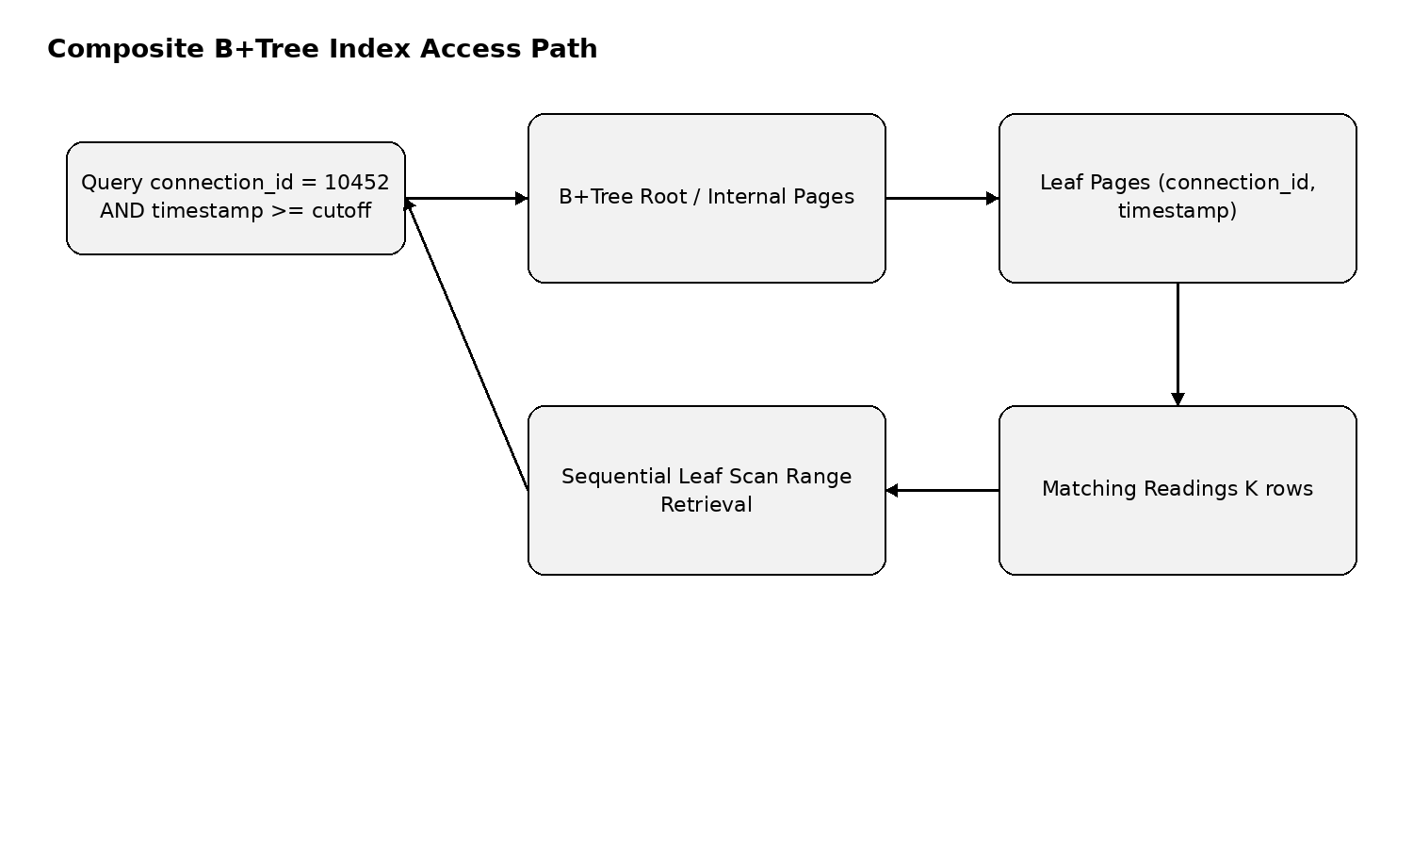
Figure 6.1: Conceptual B+Tree access path for a connection history query.

6.4 Covering Zone Index
The proposed idx_readings_zone_time_cons index contains zone_id, reading_timestamp, and consumption_liters. It is intended to support zone-level telemetry scans and aggregate analysis with fewer clustered-row accesses when the query can be satisfied from the index.

6.5 Application-Level Hash Table
The academic hash module is explicitly separate from MySQL indexing. It uses h(K) = K mod N with N chosen as a prime bucket count such as 1031. Collisions are resolved through separate chaining. Rehashing occurs when the load factor exceeds 0.75.
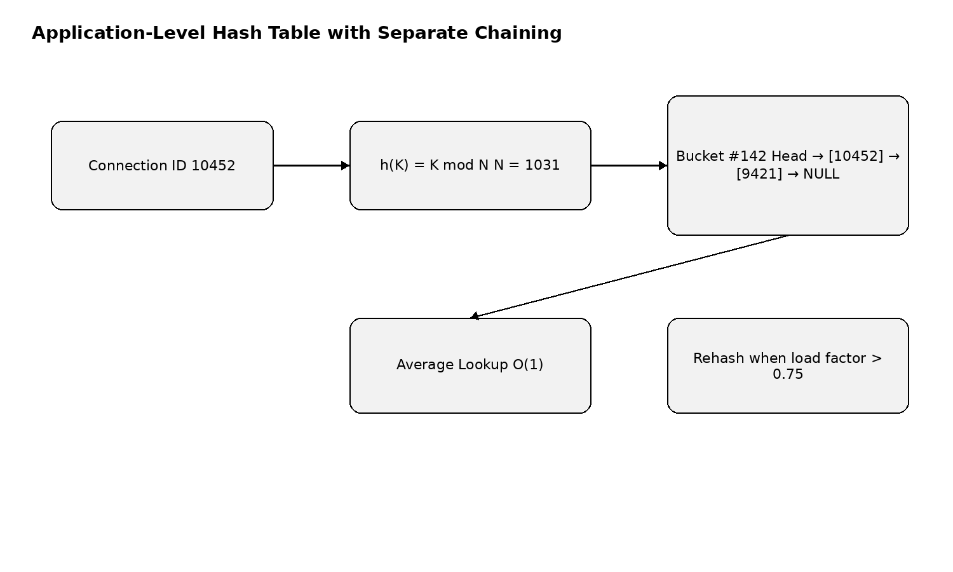
Figure 6.2: Application-level modulo hash with separate chaining.

6.6 Complexity Discussion
Hash lookup is expected O(1) when the load factor and distribution remain controlled. B+Tree lookup is O(log_B N), while a connection-specific time range is O(log_B N + K), where K is the number of returned readings.

6.7 Summary
This chapter establishes a defensible academic distinction between relational B+Tree indexing and application-level hashing.

CHAPTER 7: TRANSACTION MANAGEMENT AND CONCURRENCY CONTROL

7.1 ACID Principles
Property | SMARTFLOW Demonstration
Atomicity | Multi-table bill/payment changes commit together or roll back
Consistency | Keys, checks, unique constraints, and business rules protect valid states
Isolation | InnoDB row locking and isolation levels control concurrent access
Durability | Committed changes rely on InnoDB recovery mechanisms

7.2 Billing Transaction
Bill generation begins a transaction, locks the target connection, checks the billing cycle, calculates consumption, inserts the bill and line items, records an audit event, and commits. A duplicate attempt is rejected by the unique connection/cycle invariant.

7.3 Payment Transaction
Payment posting locks the target bill row, validates the outstanding amount, inserts the immutable payment ledger entry, updates paid_amount and due_amount, changes status, and commits. A failure triggers rollback.

7.4 Savepoints
Savepoints provide a partial rollback point inside a larger transaction. SMARTFLOW uses a savepoint before sensitive sub-operations so a failed step can be undone without necessarily discarding the entire parent transaction when the workflow permits it.
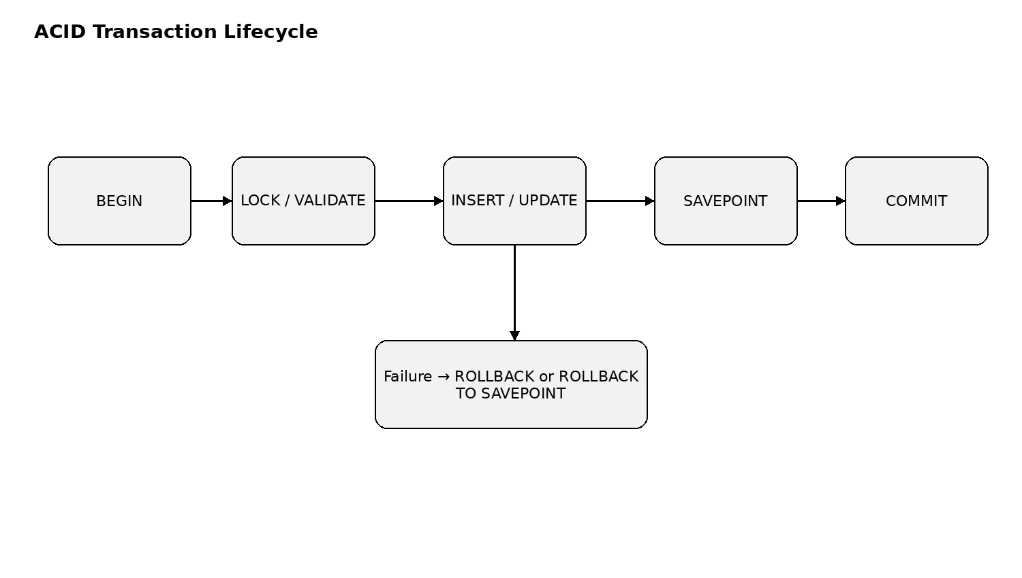
Figure 7.1: ACID transaction lifecycle with savepoint and rollback paths.

7.5 Pessimistic Concurrency Control
SELECT ... FOR UPDATE is used where a workflow needs to serialize updates to the same row. This is particularly relevant to bill and payment mutations.

7.6 Optimistic Concurrency Control
Complaints contain a version field. An update includes the previously observed version in its WHERE clause. If no row is affected, the application reports a state conflict rather than silently overwriting another operator's update.

7.7 Double Billing Race
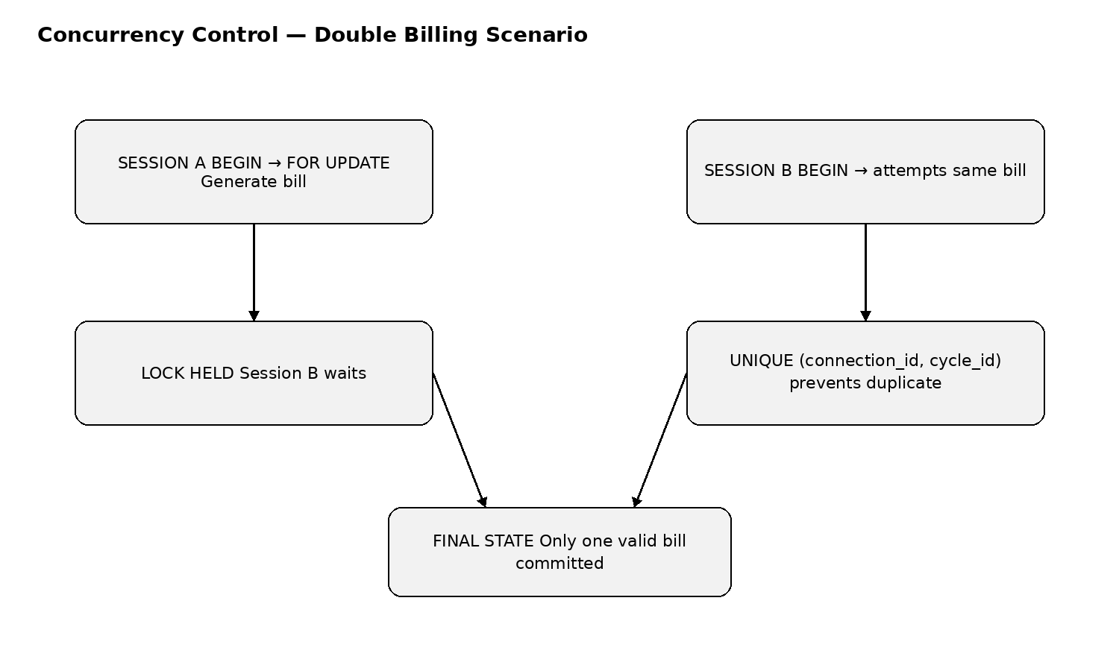
Figure 7.2: Conceptual dual-session double-billing concurrency experiment.

7.8 Summary
The transaction and concurrency design directly connects database theory to operational utility workflows.

CHAPTER 8: LEAK INTELLIGENCE AND ANALYTICS

8.1 Introduction
Leak Intelligence is designed as a statistical anomaly-detection feature rather than as an opaque AI claim. It compares recent consumption with a historical baseline and assigns an operational risk tier.

8.2 Baseline Calculation
For the last M readings, the baseline is the mean historical consumption: Baseline = (1/M) × Σ consumption_i. The current deviation is calculated as ((Current − Baseline) / Baseline) × 100, subject to protection against a zero baseline.

8.3 Risk Classification
Risk | Deviation / Flow Signal | Action
NORMAL | ≤ +30% | Routine monitoring
MODERATE | +30% to +75% | Customer notification / inspection check
HIGH | +75% to +150% | Field inspection within operational target
CRITICAL | > +150% or extreme flow signal | Urgent investigation / shut-off workflow

8.4 Detection Workflow
The workflow retrieves a recent telemetry window, computes a baseline, compares the latest reading, applies the risk rules, and presents the result on the Leak Intelligence page. A critical result can be linked to complaint creation.

8.5 Data Integrity Considerations
The anomaly score is only as reliable as the meter readings. The implementation should therefore distinguish normal readings from reverse-flow, tamper, no-flow, and suspected-leak statuses.

8.6 Summary
The analytics layer provides a transparent rule-based mechanism that can be demonstrated with controlled test data.

CHAPTER 9: QUERY PROCESSING AND OPTIMIZATION

9.1 Query Lab Objective
The Query Lab is designed to make query optimization observable. Each scenario contains a baseline query and an optimized form, followed by live EXPLAIN information and execution measurements.

9.2 Query Scenarios
Scenario | Optimization Focus
Latest reading | Materialized latest-reading lookup / indexed access
Six-month history | Composite connection + timestamp index
Zone leak scan | Zone/time/consumption covering index
Outstanding reconciliation | Indexed joins and pre-aggregation
Payment settlement | Time and payment-method access path
Complaint triage | Zone/status composite index

9.3 SARGability
Predicates should be written so the indexed column can be compared directly. For example, a timestamp range should avoid applying DATE() or another function to the indexed timestamp when that transformation prevents efficient index range access.

9.4 EXPLAIN Evidence
The final report should contain actual EXPLAIN or EXPLAIN ANALYZE screenshots from the implemented database. Expected access types such as ALL, ref, range, or const must be reported from observed output, not assumed in advance.

9.5 Benchmark Metrics
- Wall-clock query latency using a high-resolution timer.
- Access type from EXPLAIN output.
- Rows examined or equivalent optimizer statistics.
- Query throughput under controlled concurrency.
- Comparison across multiple dataset sizes.

9.6 Summary
The Query Lab turns query optimization into a measurable academic experiment.

CHAPTER 10: IMPLEMENTATION

10.1 Implementation Status
The supplied SMARTFLOW material is an implementation plan and architecture specification. It describes the intended React, Node.js, TypeScript, mysql2, and MySQL implementation, but it does not by itself prove that every listed module has been executed successfully. Therefore, this chapter documents the implementation structure while leaving execution evidence to be inserted after the system is actually run.

10.2 Project Structure
smartflow/
frontend/
backend/
database/
docs/
.env.example
package.json
README.md

10.3 Database Scripts
The planned database layer is organized into SQL scripts covering schema creation, constraints and indexes, seed data, domain operations, DBMS lab scenarios, and benchmark support. The final repository should contain executable scripts rather than only documentation.

10.4 Backend Services
The backend is planned around an Express API, mysql2 connection pool, repository/data-access layer, authentication and RBAC middleware, transaction coordinators, hash engine, query profiler, concurrency simulator, and benchmark runner.

10.5 Frontend Implementation
The frontend is planned as a React application with a civic-tech command-center theme. It should provide data-dense tables, KPI cards, charts, modals, filters, toast notifications, and responsive layouts while keeping headings and labels readable.

10.6 Academic Demo Mode
The proposed guided demo contains scenarios for schema/constraints, indexing, hashing, leak detection, billing protection, transactions, concurrency, benchmarking, and auditability. These should be connected to real system actions before being described as live.

10.7 Screenshots to Insert
Evidence | Required Actual Output
Database schema | MySQL Workbench/CLI with 13 tables
Index proof | SHOW INDEX output
Query plans | Before/after EXPLAIN output
Transactions | Actual commit, rollback, savepoint trace
Concurrency | Two real sessions or simulator output
Hashing | Actual collision/chain metrics
Dashboard | Running application screenshot
Reports | Actual generated CSV/print view

10.8 Summary
The implementation chapter is deliberately evidence-aware. It can be finalized after the implementation is run and screenshots/logs are captured.
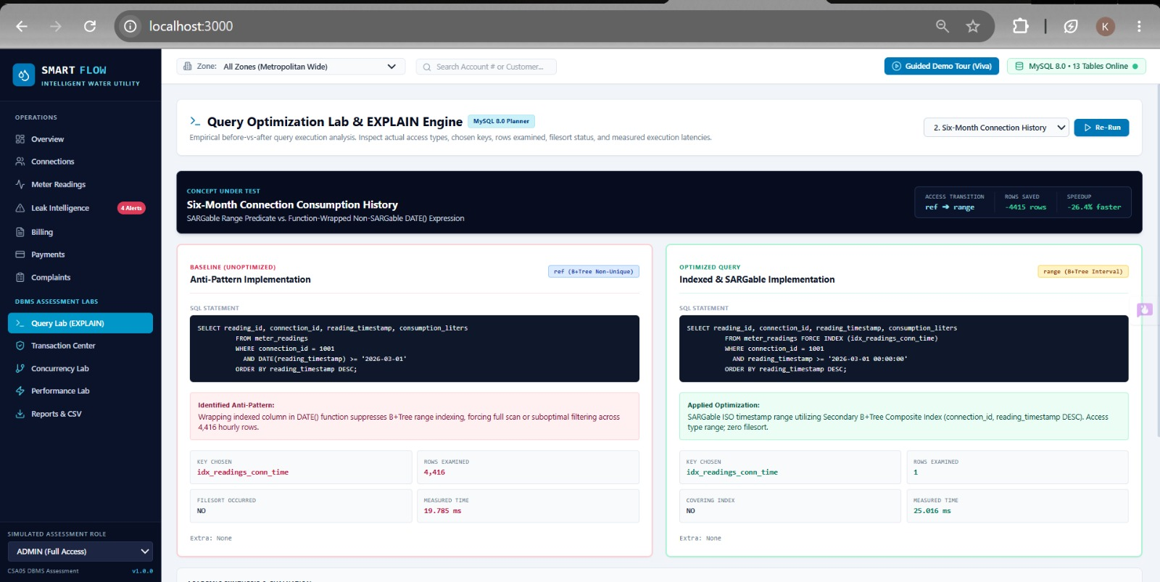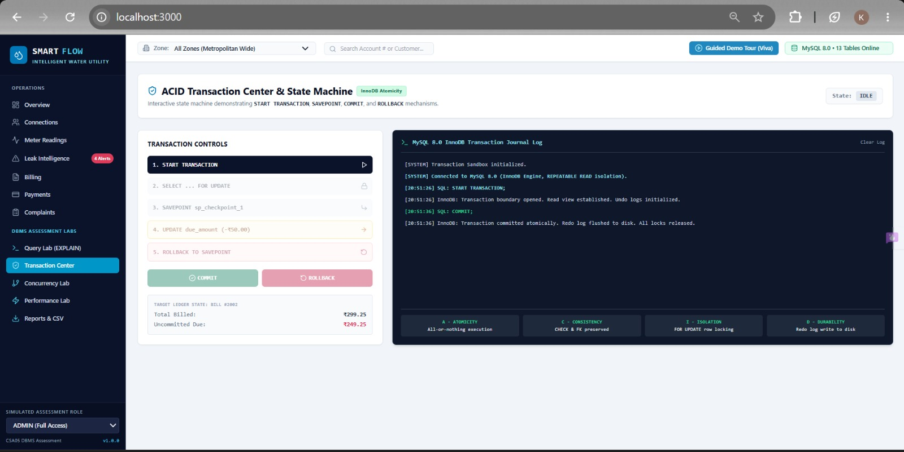

CHAPTER 11: TESTING, RESULTS AND DISCUSSION

11.1 Testing Strategy
Testing should cover constraints, transactions, concurrency, indexing, hashing, leak analytics, security, and user workflows. Each test should record the input, observed output, pass/fail status, and evidence file.

11.2 Database Tests
Test ID | Scenario | Expected Result
TC-DB-01 | Duplicate bill | Second insert rejected by unique constraint
TC-DB-02 | Negative payment | Rejected by CHECK constraint
TC-TX-01 | Bill item failure | Transaction rolls back
TC-TX-02 | Savepoint rollback | Sub-operation restored while parent continues where valid
TC-CC-01 | Concurrent billing | Only one bill committed
TC-CC-02 | Concurrent payment/update | Row locking prevents lost update
TC-IDX-01 | History query | Index-based range access observed
TC-HSH-01 | Hash lookup | Lookup returns same latest state as DB
TC-LEAK-01 | 300% deviation | CRITICAL classification

11.3 Results Reporting
Results must be reported from actual executions. If a test has not been executed, its status should remain Pending Execution. The report should never convert planned measurements into fabricated results.

11.4 Performance Discussion
The expected experimental comparison is between an unoptimized scan, an indexed query, and an application-level hash lookup. The final conclusion should be based on measured latency and access plans on the chosen machine and dataset.

11.5 Usability Discussion
The interface should minimize cognitive load through consistent navigation, clear hierarchy, readable tables, descriptive empty states, loading skeletons, and visible success/error feedback.

11.6 Limitations
Benchmark results can vary by hardware, buffer pool state, dataset distribution, cache warmth, concurrent load, and MySQL configuration. Application-level hash performance should also be interpreted separately from durable database indexing because the hash table resides in application memory.

11.7 Summary
This chapter provides a defensible framework for converting implementation output into final academic results.

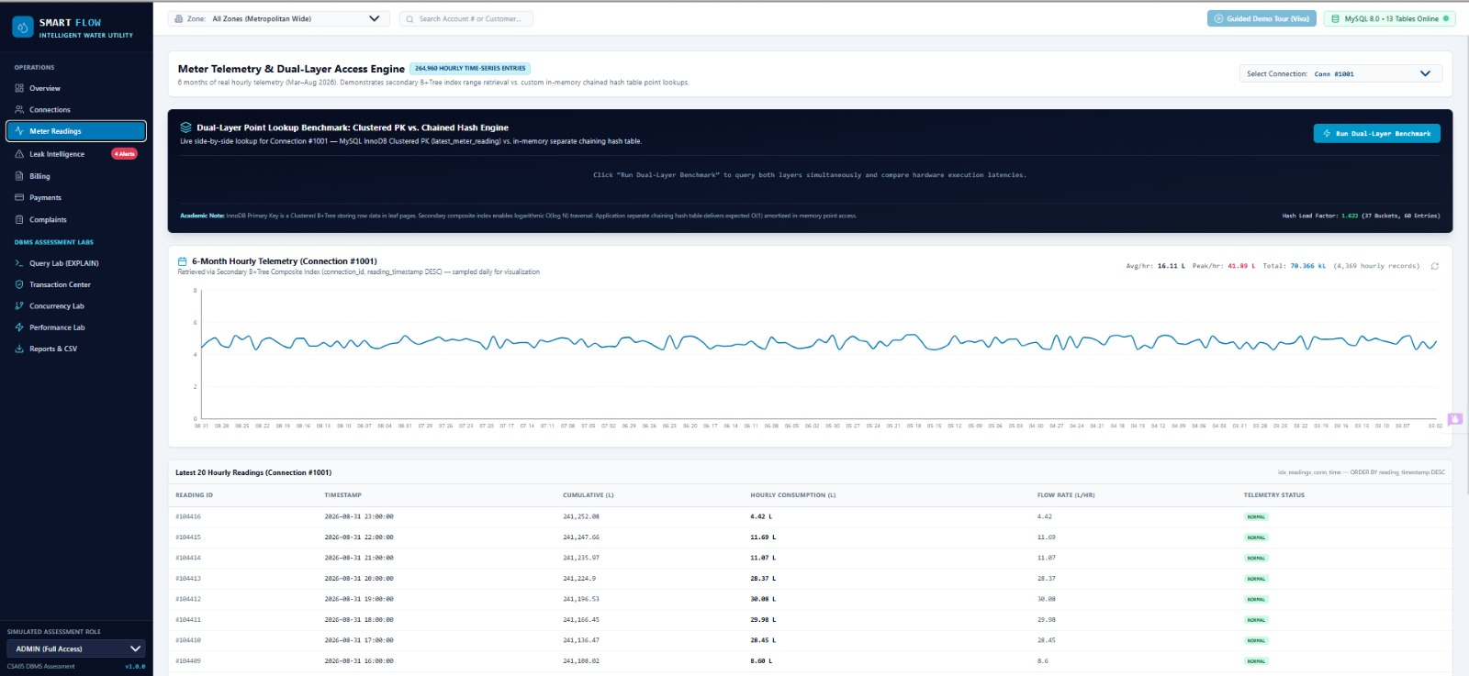
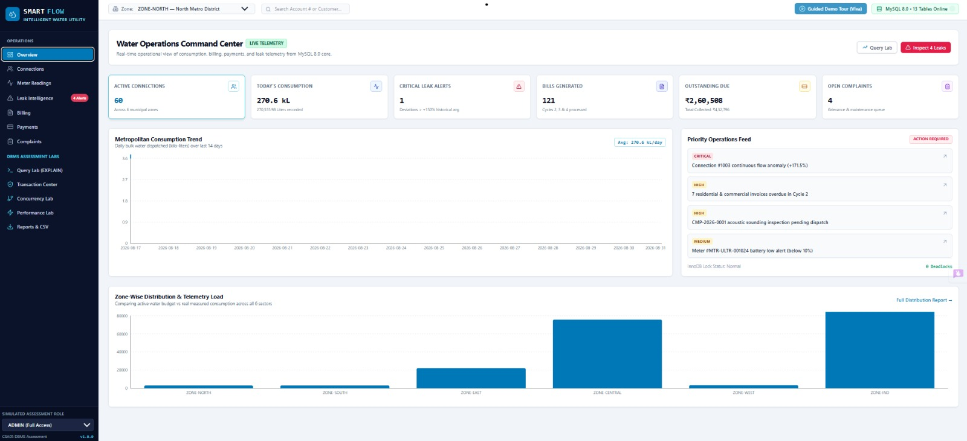

CHAPTER 12: SECURITY, CONCLUSION AND FUTURE ENHANCEMENTS

12.1 Security Architecture
- Parameterized SQL statements through mysql2 placeholders.
- Environment variables for database credentials.
- Password hashing rather than plaintext storage.
- Role-based authorization for protected modules.
- Audit records for critical financial and operational mutations.
- Validation of user input before database operations.

12.2 Auditability
The audit_logs table is intended to provide forensic visibility into billing, payment, complaint, and rollback actions. Audit records should contain the acting user, entity, action type, details, and timestamp.

12.3 Conclusion
SMARTFLOW presents a comprehensive Database Management Systems capstone design for intelligent municipal water utility management. The project combines a normalized relational schema with high-volume telemetry handling, composite B+Tree indexing, application-level hashing, statistical leak detection, transaction processing, concurrency control, query optimization, benchmarking, and role-based security.
The major academic strength of the design is that each DBMS concept is tied to a concrete utility workflow. Billing demonstrates uniqueness and transaction safety; payments demonstrate atomic balance reconciliation; complaints demonstrate optimistic concurrency; telemetry demonstrates indexing and range access; Query Lab demonstrates execution plans; and the Performance module demonstrates measurement.

12.4 Future Enhancements
- Real-time streaming ingestion from smart meters.
- Message queues for high-volume telemetry ingestion.
- Advanced statistical or machine-learning leak prediction.
- GIS-based network visualization.
- SMS/email notification integration.
- Mobile applications for field engineers and customers.
- Horizontal scaling and partitioning for very large telemetry volumes.
- Advanced observability with metrics and distributed tracing.

12.5 Final Statement
SMARTFLOW is intended to demonstrate not only a functional utility-management interface but also the reasoning behind database organization, indexing, transaction safety, concurrency control, and performance. Final claims should be supported by actual execution evidence collected from the completed implementation.
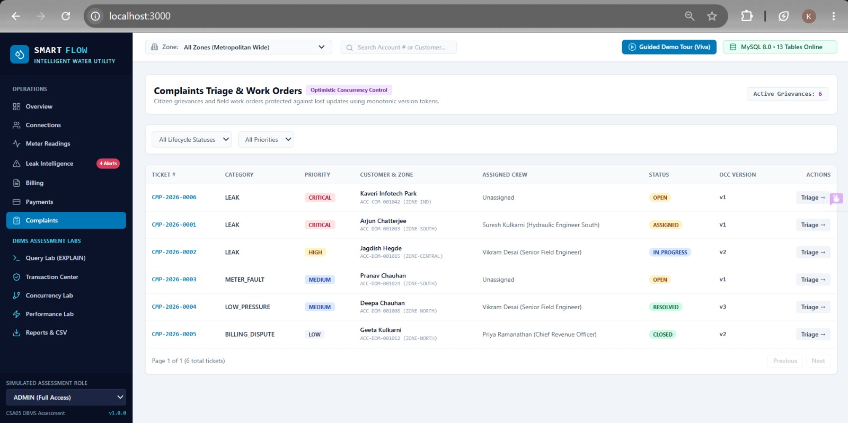

REFERENCES
- Silberschatz, A., Korth, H. F., & Sudarshan, S. Database System Concepts. McGraw-Hill.
- Elmasri, R., & Navathe, S. B. Fundamentals of Database Systems. Pearson.
- Oracle Corporation. MySQL 8.0/8.4 Reference Manual.
- Node.js Documentation. Node.js Runtime and API Documentation.
- Express.js Documentation. Express Web Framework Documentation.
- React Documentation. React User Interface Library Documentation.
- TypeScript Documentation. TypeScript Language Handbook.
- Tailwind CSS Documentation. Utility-First CSS Framework Documentation.
- Recharts Documentation. React Charting Library Documentation.

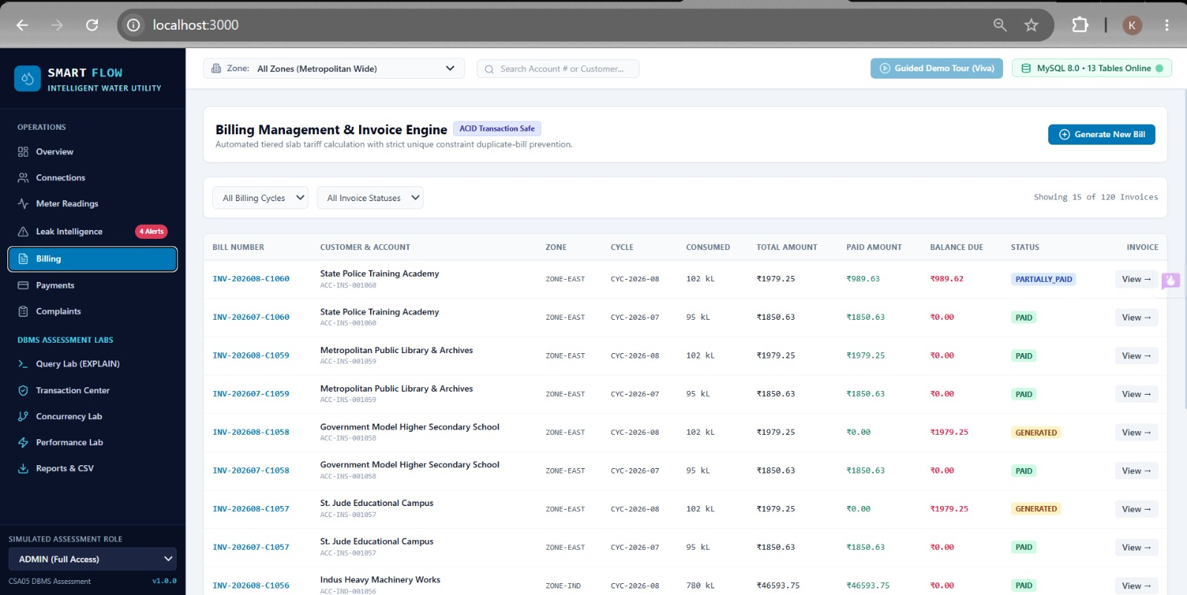

APPENDICES

Appendix A – Complete Table List
No. | Table
1 | users
2 | zones
3 | connections
4 | meters
5 | meter_readings
6 | latest_meter_reading
7 | billing_cycles
8 | bills
9 | bill_items
10 | payments
11 | complaints
12 | complaint_history
13 | audit_logs

Appendix B – Key SQL Patterns
SELECT connection_id, reading_timestamp, consumption_liters FROM meter_readings WHERE connection_id = ? AND reading_timestamp >= ? ORDER BY reading_timestamp DESC;
SELECT connection_id, cycle_id FROM bills WHERE connection_id = ? AND cycle_id = ? FOR UPDATE;
SELECT bill_id, total_amount, paid_amount, due_amount FROM bills WHERE bill_id = ? FOR UPDATE;
UPDATE complaints SET status = ?, version = version + 1 WHERE complaint_id = ? AND version = ?;

Appendix C – Evidence and Screenshot Checklist
No. | Evidence
1 | Database schema and foreign keys
2 | Constraints / duplicate rejection
3 | Composite index output
4 | Unindexed EXPLAIN
5 | Indexed EXPLAIN
6 | Hash comparison
7 | Transaction commit
8 | Transaction rollback
9 | Savepoint
10 | Concurrency race
11 | Dashboard
12 | Connection 360 view
13 | Telemetry table
14 | Leak Intelligence
15 | Billing invoice
16 | Payment receipt
17 | Complaint board
18 | Query Lab
19 | Transaction Center
20 | Concurrency Lab
21 | Performance benchmark
22 | Audit trail
23 | CSV export
24 | RBAC restriction
25 | Guided demo scenario

Appendix D – Figure Index
Figure | Title
3.1 | SMARTFLOW three-layer architecture
3.2 | Operational workflow
4.1 | Functional module map
4.2 | Simplified ER design
6.1 | B+Tree access path
6.2 | Application-level hashing
7.1 | ACID transaction lifecycle
7.2 | Concurrency experiment

Appendix E – Report Finalization Notes
Replace every placeholder for student names, guide, institution, dates, screenshots, execution plans, measured benchmarks, and actual test results before submission. Update the Table of Contents after final formatting in Microsoft Word.

